CSS 255 Design Document

Matthew Cohen

UML Diagrams

Use Case Diagram

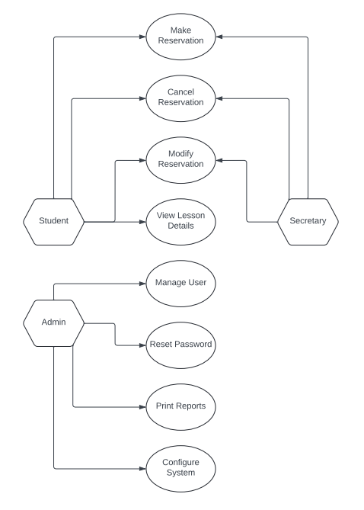

Activity Diagrams

Reset Password

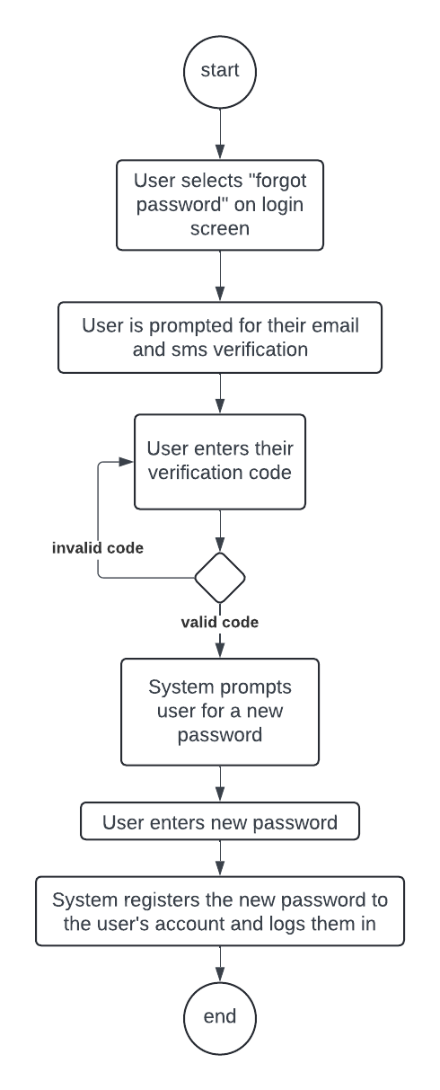

Make a Reservation

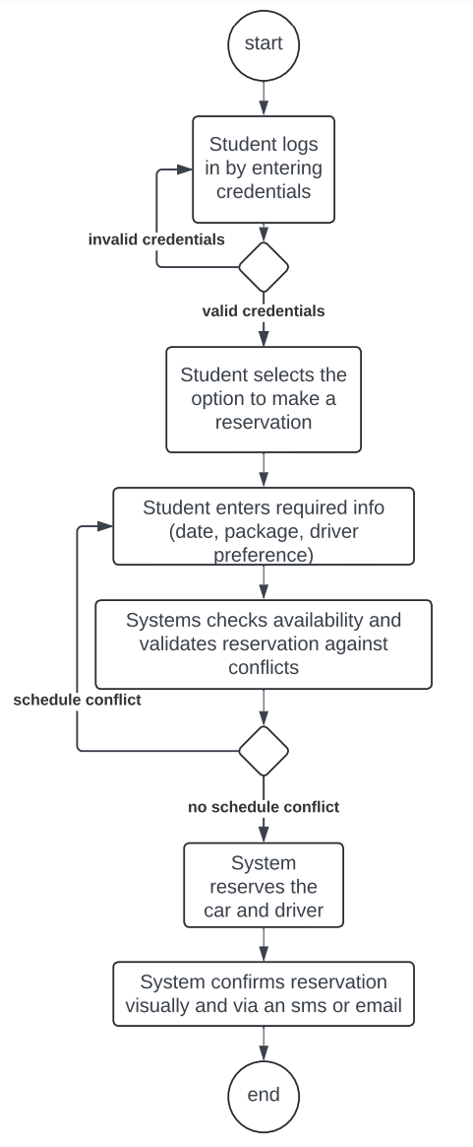

Sequence Diagram

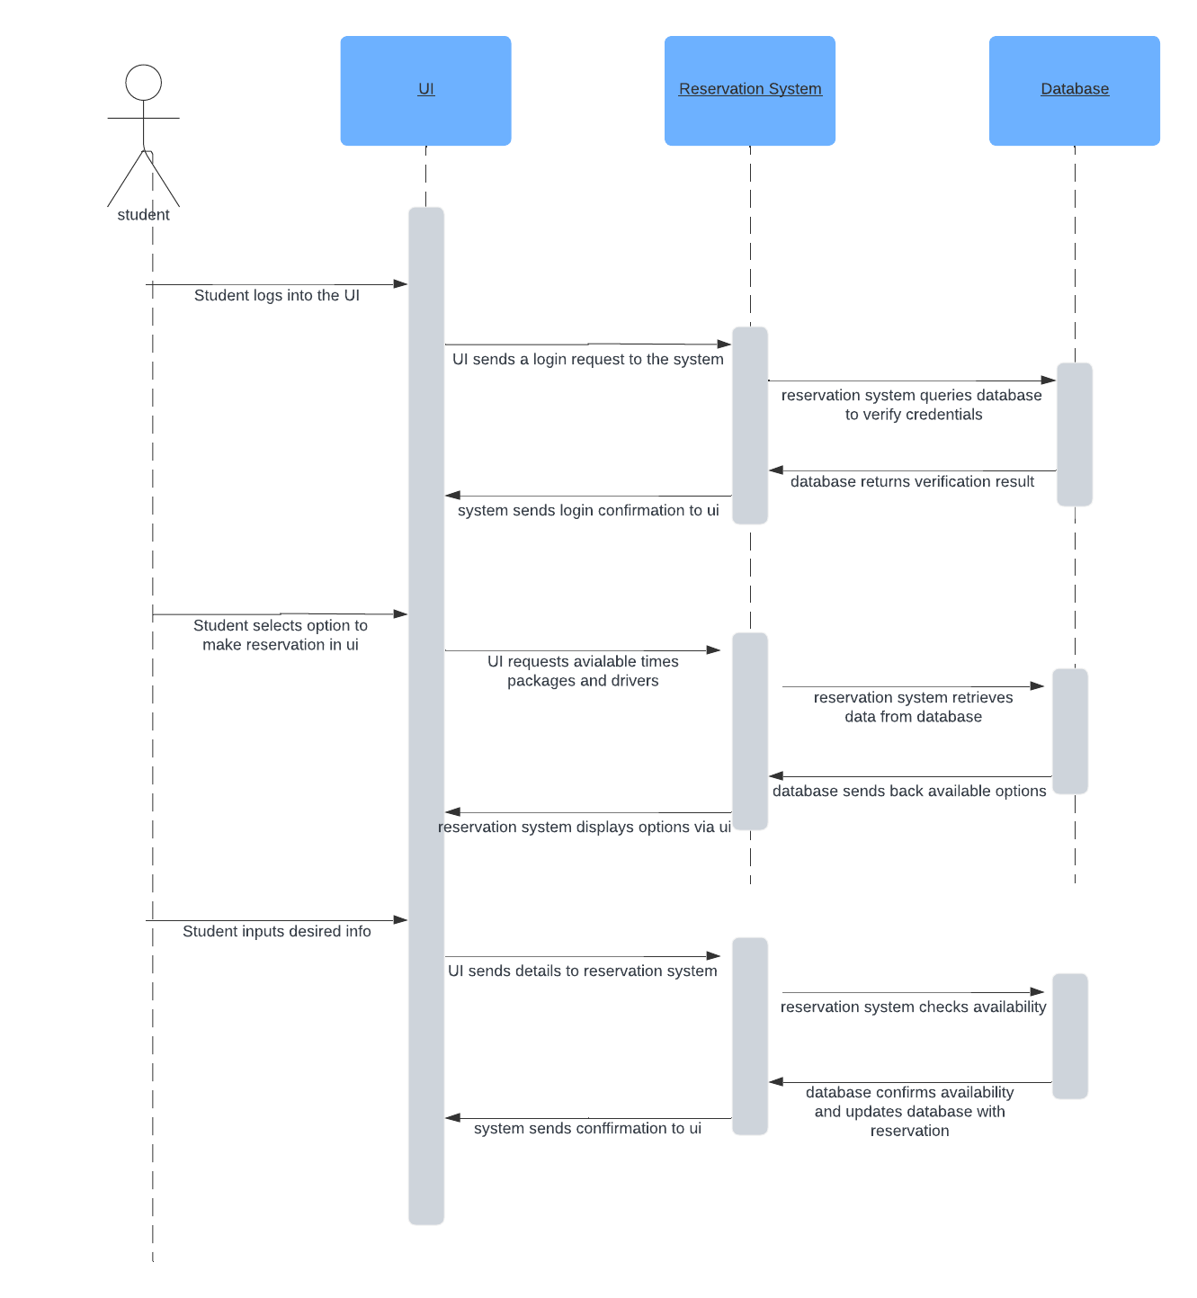

Class Diagram

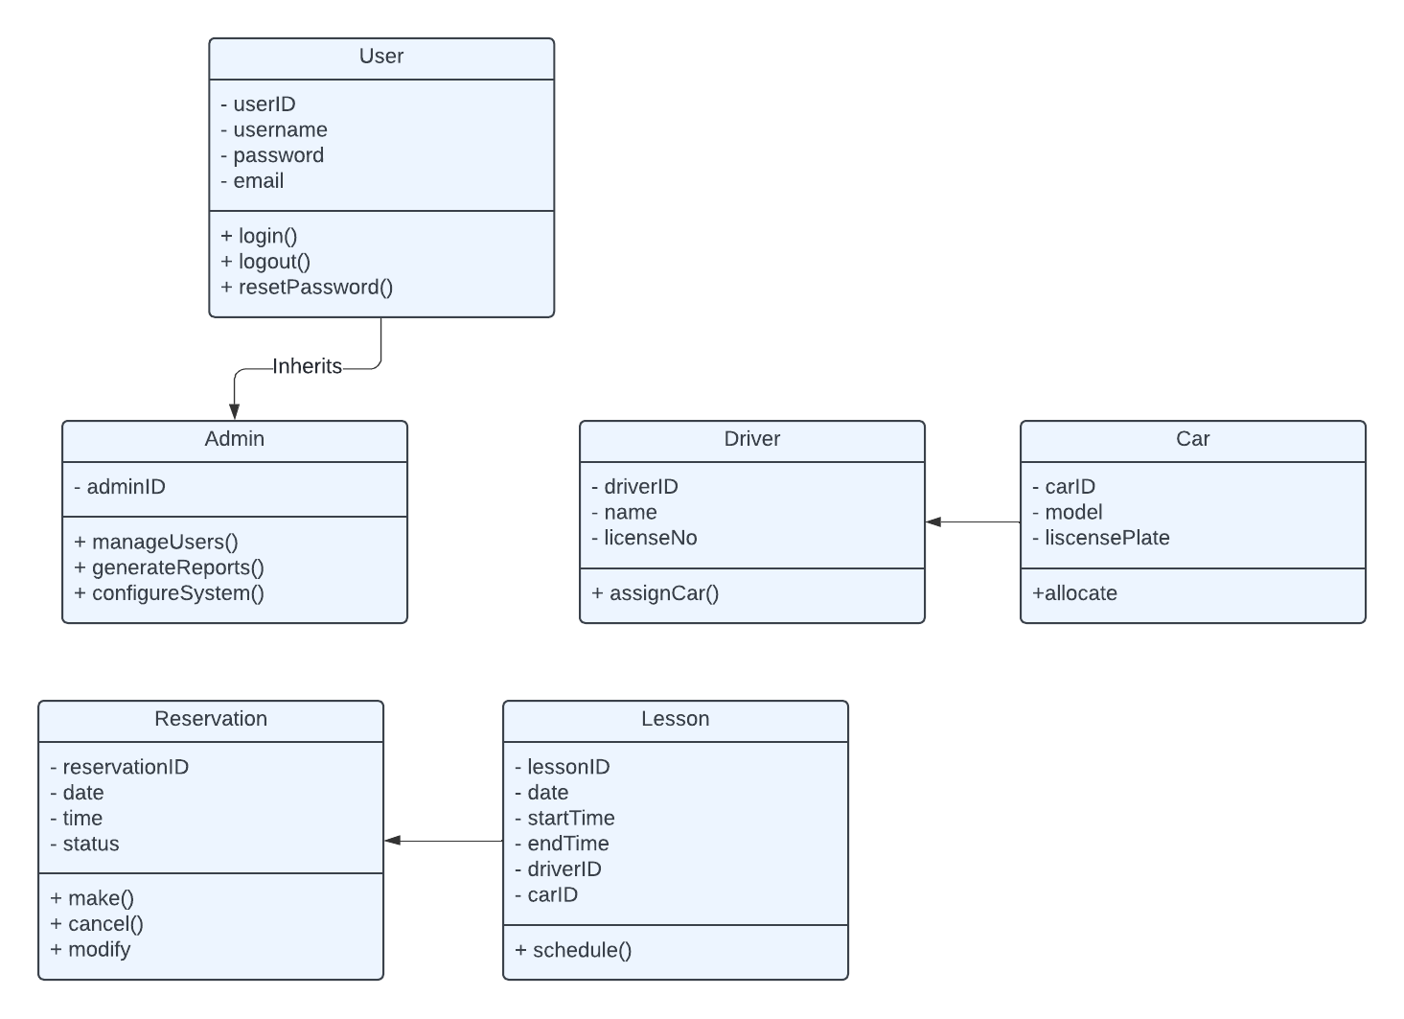

Technical Requirements

Hardware Requirements

Servers: Reliable cloud servers for hosting the application and database (e.g., AWS EC2 instances).

User Devices: Compatibility with modern smartphones, tablets, and desktops for accessing the web interface.

Software Requirements

Operating Systems: Support for major operating systems including Windows, iOS, and Android for user access.

Database Management System: SQL database for storing user data, reservation details, and logs (e.g., MySQL, PostgreSQL).

Web Server Software: Robust web server software for handling web requests (e.g., Apache, Nginx).

Tools

Development Frameworks: Use of modern web development frameworks (e.g., React for front-end, Node.js for back-end) to ensure a responsive and dynamic user interface.

IDEs: Integrated Development Environments like Visual Studio Code or JetBrains IntelliJ IDEA for software development.

Version Control: Git repository hosting service (e.g., GitHub, GitLab) for code management and version control.

Infrastructure

Cloud Services: Cloud platforms for hosting the application, database, and potentially for offsite backups and disaster recovery (e.g., AWS, Google Cloud Platform).

Security Tools: Encryption tools for secure data transmission (SSL/TLS certificates), and robust firewall and antivirus software to protect servers and data.

Monitoring and Logging Tools: Systems for monitoring server performance and logging application activities (e.g., Datadog, Splunk).

Communication and Integration

APIs: RESTful APIs for seamless integration with external services like DMV updates or third-party payment gateways.

Email/SMS Services: Integration with email and SMS gateways for notifications (e.g., SendGrid, Twilio).